[Slide Air 1]

Cargo Securing at Air Transport
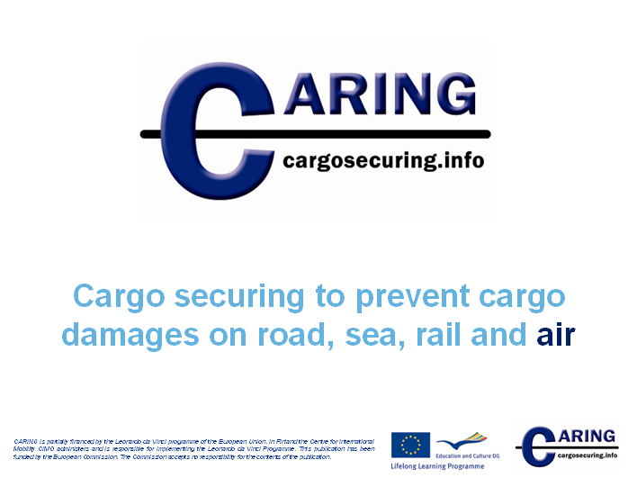

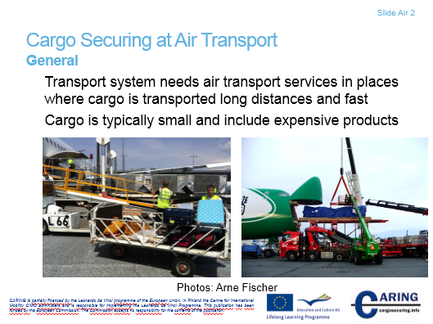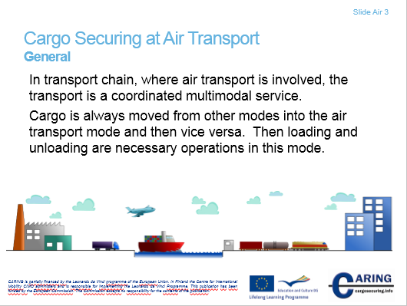[Slide Air 2 & 3]

Cargo Securing at Air Transport

General
Transport system needs air transport services in places where cargo is transported long distances and fast. Cargo is typically small, when it is transported in passenger aircraft’s belly department. Cargo aircrafts can carry also heavy cargo. In addition, airfreight is used, when a product is expensive and at the same time the distance is long.
Regarding the airfreight, the transportation system is a coordinated multimodal service. Multimodal means that cargo is transported by one mode to air port’s terminal or warehouse then unloaded and after that reloaded into an aircraft. As a matter of fact this transportation system needs a land delivery services for the final or first leg of the journey. The land delivery is transported mainly by road.
The goods need to be delivered to end-users within a limited time window. With the limited time window we mean a short period, especially with regards to express services.
Notes
__________________________________________________________________________________
__________________________________________________________________________________
__________________________________________________________________________________
__________________________________________________________________________________
__________________________________________________________________________________
__________________________________________________________________________________

[Slide Air 4]
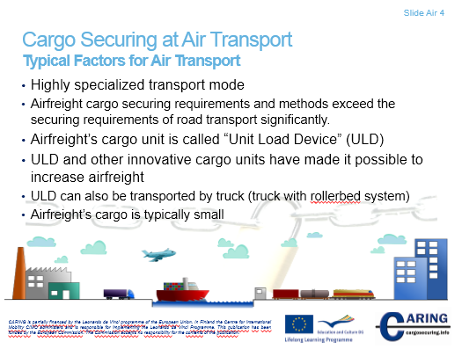

Typical factors for air transport
Airfreight is highly specialized transport mode, which typically transports small cargo. Small cargo can be transported by passenger aircraft. Large cargo can be transported by cargo aeroplanes. The weight of the cargo varies a lot.
The material flow “stops” in air freight terminal because of cargo securing rules. Airfreight cargo securing requirements and methods exceed the securing requirements of road transport significantly and that’s why material handling is necessary in terminal.
Airfreight’s cargo unit is called “Unit Load Device” (ULD). The name can be regarded as slang word within airfreight operators. The ULD can be a specifically designed box for carrying packages or strictly specified way lashed and secured cargo unit for instance on a pallet. The cargo unit must be specifically designed, because strong forces towards cargo will be created in the start of the flight, at the end of the flight and in the air.
ULD and other innovative cargo units have made possible to increase airfreight. ULD suites also to road-air transport system well. Airfreight is door-to-door system, where the final leg is carried by a truck or van. Typically, the Rollerbed System in trucks are used, because they are fast to load and unload.

Notes
__________________________________________________________________________________
__________________________________________________________________________________
__________________________________________________________________________________
__________________________________________________________________________________
__________________________________________________________________________________
__________________________________________________________________________________
__________________________________________________________________________________
__________________________________________________________________________________

[Slide Air 5]
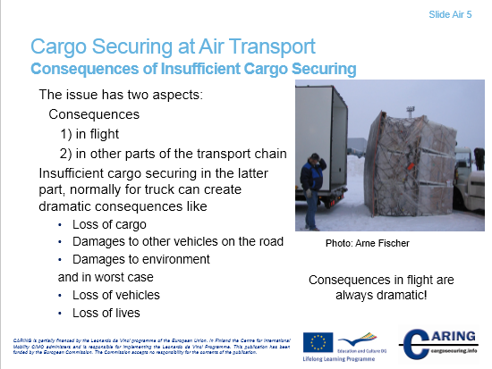

Consequences of insufficient cargo securing

Because of the nature of multimodal transport system the consequences have two aspects: 1) consequences in flight and 2) consequences in other parts of the transport chain.
The cargo securing in aircraft has to be made according to instructions so that the securing can withstand stresses that different accelerations create in flight.
Consequences that flight accident can create are always dramatic.
In the final leg of the cargo’s journey (or in the first leg) truck or van is used. Insufficient cargo securing in this vehicle consequences can be dramatic in the form of:
- Loss of cargo
- Damages to other vehicles on the road
- Damages to environment

Notes
__________________________________________________________________________________
__________________________________________________________________________________
__________________________________________________________________________________
__________________________________________________________________________________

[Slide Air 6]
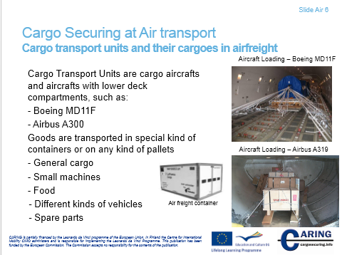
Cargo Transport Units and their Cargoes in airfreight
In airfreight a cargo aircraft and a passenger aircraft are Cargo Transport Units. Passenger aircrafts carry goods in their belly department. Goods are transported in a special kind of container or on a pallet. This cargo transport unit is called Unit Load Device (ULD). Goods on pallet are always covered by tarpaulin or a net, so that the cargo unit is tight and withstand stresses that accelerations create.
Typical cargoes are:
- General cargo
- Small machines
- Food
- Different kinds of vehicles, for instance cars and motorcycles
- Spare parts

Notes
__________________________________________________________________________________
__________________________________________________________________________________
__________________________________________________________________________________
__________________________________________________________________________________
__________________________________________________________________________________

[Slide Air 7]
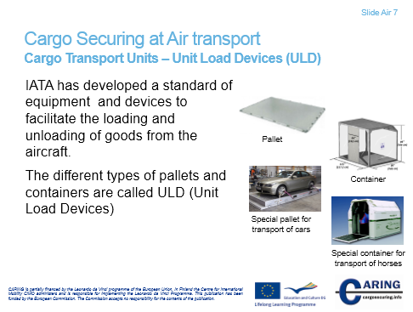
Cargo transport units – Unit Load Devices (ULD)
IATA has developed a standard of equipment and devices to facilitate the loading and unloading of goods to and from the aircraft.
The different types of pallets and containers are called ULD (Unit Load Devices). The Unit Load Device allows a large quantity of cargo to be bundled into a single unit. ULD has two forms: pallets and containers. There are wide variety of pallets and containers. Pallets are for instance rugged sheets of aluminum with rims designed to lock cargo nets. ULD containers are closed containers made usually of aluminum. If food is transported, the container includes a built-in refrigeration.
Unit Load Devices have to have also aircraft compatibility. So, this is one consideration that needs to be accounted for by the personnel of airport terminal.
The slide presents some Unit Load Devices but there are a large variety of forms available.

Notes
__________________________________________________________________________________
__________________________________________________________________________________
__________________________________________________________________________________
__________________________________________________________________________________

[Slide Air 8]
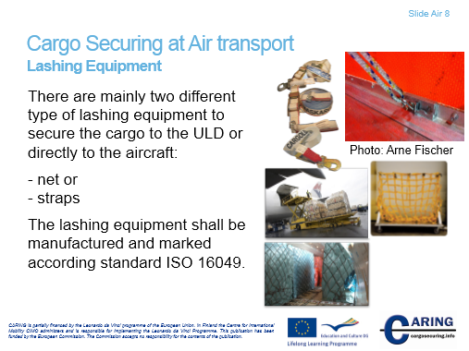
Lashing Equipment
There are mainly two different type of lashing equipment to secure the cargo to the ULD or directly to the aircraft:
- net or
- straps
The lashing equipment shall be manufactured and marked according standard ISO 16049.
Also ropes are used. Ropes and straps are fastened to rings of containers and pallets.

Notes
__________________________________________________________________________________
__________________________________________________________________________________
__________________________________________________________________________________
__________________________________________________________________________________

[Slide Air 9]
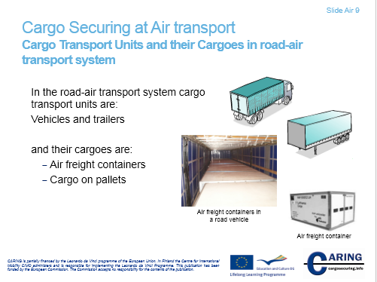

Cargo Transport Units and their Cargoes in road-air transport system
Here we have defined the multimodal transport system with road-air transport system, because mainly a truck or van is used in the first or final leg of the journey. So, in the road-air transport system cargo transport units are: vehicles and trailers. Then their cargoes are air freight containers, cargo on pallets etc.

Notes
__________________________________________________________________________________
__________________________________________________________________________________
__________________________________________________________________________________
__________________________________________________________________________________

[Slide Air 10]
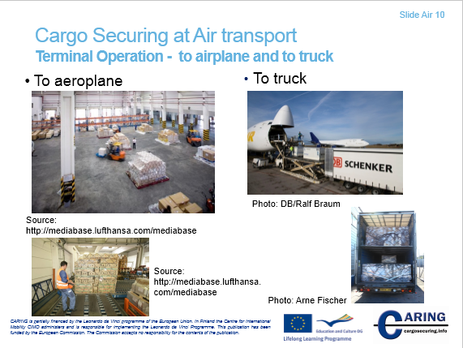

Terminal Operation – to airplane and to truck
When the cargo arrives at airport’s terminal, it is unloaded from a road vehicle and repackaged and then reloaded into the aircraft. The packaging and loading into the belly of a aeroplane is made by terminal personnel.
When the cargo arrives from the flight, the cargo will be moved to the terminal to unload from UDL and then it is repacked onto pallets, which in turn are loaded to the road vehicle.
The UDL can be loaded right away to the road vehicle, but in this case we are talking about Road Feeder Service. When UDLs are loaded to the road vehicle, typically a special vehicle (rollerbed) is needed.

Notes
__________________________________________________________________________________
__________________________________________________________________________________
__________________________________________________________________________________
__________________________________________________________________________________

[Slide Air 11]
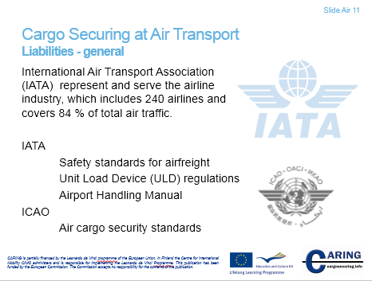
Liabilities - general
The basis for all contracts and operation procedures are created by aviation organizations IATA and ICAO. These organizations create also design and manufacturing standards for ULD. The airfreight terminal operator follows then these standards and especially the manuals of ULD manufacturers.
International Air Transport Association (IATA)
“The International Air Transport Association (IATA) is the trade association for the world’s airlines, representing some 240 airlines or 84% of total air traffic. IATA support many areas of aviation activity and help formulate industry policy on critical aviation issues."
IATA have drawn up Unit Load Device regulations. Regulations give the knowledge required to handle, transport and manage unit load devices in airport operations. Regulations give also understanding, how to handle ULDs safely, securely and efficiently. ULD regulations contain both technical and operational standards and regulatory requirements as well as the carrier's requirements applicable to overall ULD operations. Note that only airfreight is considered.
Airport handling manual covers load control, baggage, cargo and mail handling, aircraft movement control, aircraft loading, departure control systems, passenger handling. See also the slide 15, Acting forces in the air transport.
International Civil Aviation Organization (ICAO)
A specialized agency of the United Nations, the International Civil Aviation Organization (ICAO) was created in 1944 to promote the safe and orderly development of international civil aviation throughout the world. It sets standards and regulations necessary for aviation safety, security, efficiency and regularity, as well as for aviation environmental protection. The Organization serves as the forum for cooperation in all fields of civil aviation among its 191 Member States.
Sources:
http://www.iata.org/Pages/default.aspx
http://www.icao.int/Pages/default.aspx

Notes
__________________________________________________________________________________
__________________________________________________________________________________
__________________________________________________________________________________
__________________________________________________________________________________
__________________________________________________________________________________
__________________________________________________________________________________
__________________________________________________________________________________
__________________________________________________________________________________

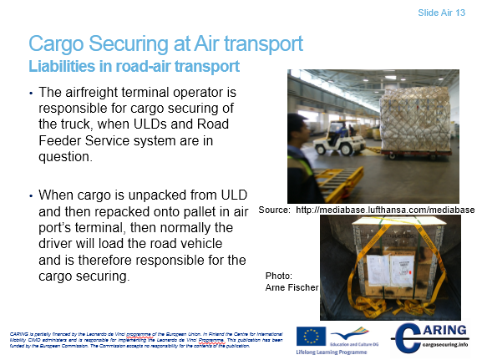[Slide Air 12 & 13]
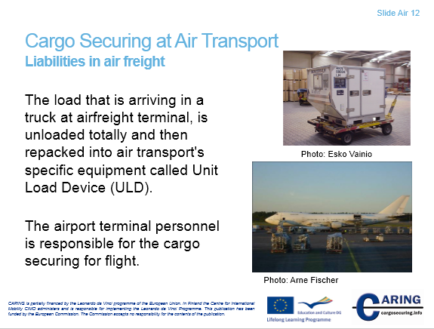
Liabilities in airfreight
The airport terminal personnel is responsible for the cargo securing for flight.
The cargo securing is done at the airport terminal supervised by a cargo master who is familiar with the rules and instruction from the actual liner and type of aircraft.
Liabilities in road-air transport
Often the personnel of the airfreight terminal operator loads a truck or van with cargo that has arrived from a flight. This is the case especially, when ULDs are loaded for Road Feeder Service system. In this case the airfreight personnel is responsible for cargo securing. Also terminal operator’s rules obliges making cargo securing. (See the definition of Road Feeder Service in the next page).
When cargo is unpacked from ULD and then repacked onto pallet in air port’s terminal, then normally the driver will load the road vehicle and is therefore responsible for the cargo securing. Cargo securing follows then EN 12195-1:2010 standard.
Notes
__________________________________________________________________________________
__________________________________________________________________________________
__________________________________________________________________________________
__________________________________________________________________________________
__________________________________________________________________________________

[Slide Air 14]
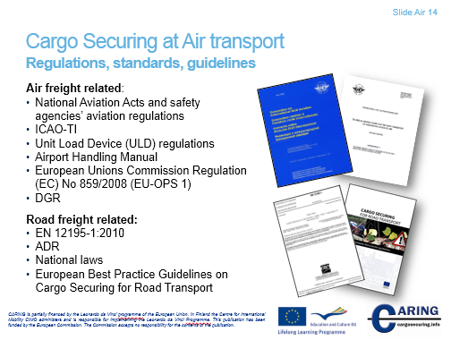
Regulations, standards and guidelines
In Cargo securing at air transport we can divide regulations, standards and guidelines into two categories: Air freight related and Road freight related.
Air freight related
National aviation act typically considers passenger and cargo flights broadly beginning with general definitions, aeroplanes and their registration and ending up to civil aviation safety and administrative issues like licensees. Cargo securing is not considered. A nation has generally a traffic and safety agency for aviation matters. Traffic and safety agency gives detail instruction about many aviation matters. One important matter regarding the cargo securing is instructions for carrying dangerous goods. Safety agency follows ICAO’s standards and instructions. For instance in Finland the safety agency follows aviation regulations OPS M1 – 18.
European Union’s Commission Regulation (EC) No 859/2008 (EU-OPS 1)
The document No 859/2008 (EU-OPS1) is a large document that covers comprehensively safety matters in operations. The document considers also loading an aeroplane and transporting dangerous goods.
ICAO-TI: Technical Instructions for the Safe Transport of Dangerous Goods by Air (2011-2012 Edition), (Doc 9284-AN/905)
Convention on International Civil Aviation (also known as Chicago Convention) determines many standards.

IATA
Information is key to any safety program, no less for dangerous goods in air transport. Through its Dangerous Goods Regulations (DGR) and a comprehensive and effective training program, IATA ensures that shippers, forwarders, and carriers have the tools and resources to ship dangerous goods safely.

Road freight related
Air transport’s cargo securing will encounter EN 12195-1:2010 standard by Road Feeder Service system that is a service offered by a scheduled cargo operator to move its carried goods to and from the aircraft by road. This service allow a carrier to offer services to a city to which it does not fly aircraft.
Also EN 12195-1:2010 is followed in normal air-truck transport chain, where airfreight cargo is unloaded from ULD and reloaded onto pallet. This operation is called “loose loading”.
In road freight national laws are followed.
Sources:
http://www.iata.org/whatwedo/cargo/dgr/Pages/index.aspx
http://www.icao.int/
http://eur-lex.europa.eu/

Notes
__________________________________________________________________________________
__________________________________________________________________________________
__________________________________________________________________________________
__________________________________________________________________________________
__________________________________________________________________________________

[Slide Air 15]
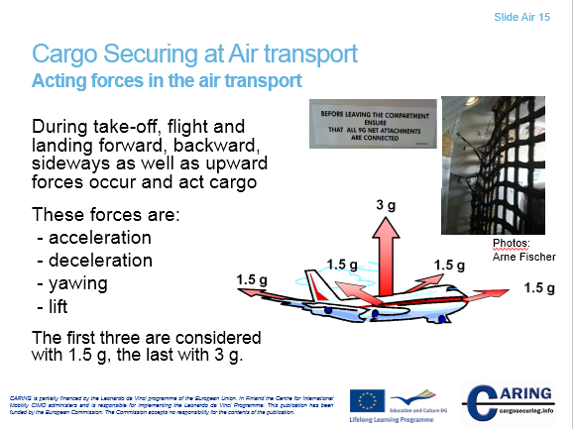
Acting forces in the air transport
The cargo securing for the airfreight is an integral part of the airfreight operations. Hence, the airport’s terminal workers are responsible for cargo securing.
In the air transport different forces occur and act cargo during take-off, flight and landing. Acting forces specifically considers forces that act cargo inside the aircraft. These forces are:
- Acceleration
- Deceleration
- Yawing
- Lift
Acting forces upward (lift) may be strong and that’s why cargo securing has to take into account such force as 3 g.
Cargo has to be secured so that lashing or blocking bears 1,5 times the weight of the cargo forwards, backwards and transverse direction.
IATA Airport handling manual AHM 450 determines load restrained forces in Standardization of Gravity Forces as follows:
It is recommended that, when no other values (in accordance with the aircraft’s Weight and Balance Manual) are available the following standard gravity (g) force values are used for load securing instructions and requirements of lashing equipment in both compartments and main decks:
• Forward 1.5 g (9 g in the cabin and main deck if a secure bulkhead is missing)
• Backward 1.5 g
• Sideways 1.5 g
• Upwards 3 g
Commentary
There are differences in the restraint requirements (g forces) for each type of aircraft by national aviation authorities and aircraft manufacturers. Uniformity will reduce the risk of loading errors arising from procedures differences, punctuality will be protected and staff training made easier.

Notes
__________________________________________________________________________________
__________________________________________________________________________________
__________________________________________________________________________________
__________________________________________________________________________________
__________________________________________________________________________________
__________________________________________________________________________________
__________________________________________________________________________________
__________________________________________________________________________________

[Slide Air 16]
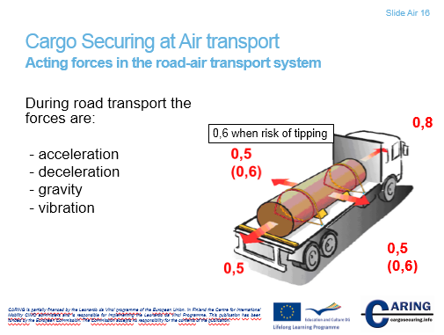
Acting forces in the road-air transport system
The journey starts for instance at off-site depot and goes to airport terminal. Off-site depot is for instance a warehouse.
Emphasize here that the driver has to follow standard EN 12195-1:2010. Accordingly, acting forces are the same as in road transport. When the journey starts at airport terminal, in loose cargo situation the forces are the same as in road transport. In situation where ULDs are transported acting forces are the same as in road transport, though the goods in ULD are secured according to standards of air transport’s cargo securing.

Notes
__________________________________________________________________________________
__________________________________________________________________________________
__________________________________________________________________________________
__________________________________________________________________________________
__________________________________________________________________________________
__________________________________________________________________________________
__________________________________________________________________________________
__________________________________________________________________________________

[Slide Air 17]
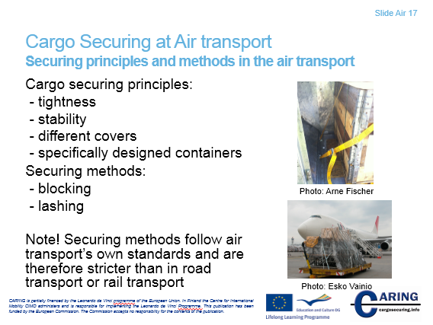
Securing principles and methods in the air transport
Cargo securing in the air transport follows the principles:
- Tightness
- Stability
- Different covers
- Specifically designed containers
- Mostly used securing methods are blocking and lashing.
- Note that securing methods follow air transport’s own standards and securing is stricter and demanding than securing in road or rail transport.
Notes
__________________________________________________________________________________
__________________________________________________________________________________
__________________________________________________________________________________
__________________________________________________________________________________
__________________________________________________________________________________
__________________________________________________________________________________
__________________________________________________________________________________

[Slide Air 18]
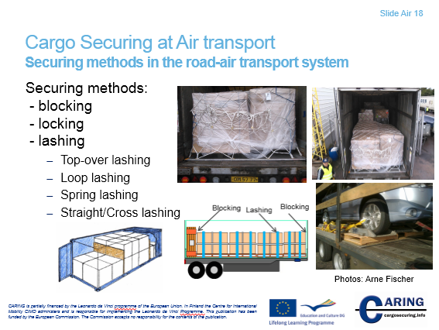
Securing methods in the road-air transport system
When taking into account the road-air transport system, then follow European Standard EN12195-1:2010. Securing methods are:
- Blocking
- Locking
- Lashing
  - Top-over lashing (frictional lashing)
  - Loop lashing
  - Spring lashing
  - Straight/Cross lashing

When the rollerbed system is in question the operation of loading and securing is implemented as follows:
The rollerbed system has three or four rollconveyors in the platform of cargo transport unit. Rollconveyors facilitate to move cargo into the load carrier.
Pneumatic or non-powered roller track or roll conveyor in truck's platform has long been used to convey air cargo pallets and airfreight containers into truck. In the truck's cargo transport unit there are three or four roller tracks that can be raised up from the slots of the floor. When cargo units have been pulled into the truck the roller tracks are lowered, so that cargo units rest on the wooden floor. The wooden floor can be covered with anti-slip material so as to increase friction.
Side walls hinder the transverse movement and ULDs themselves are blocked with each other in longitudinal direction. If needed, additional bars or batten are used. The cargo on or in the ULD is secured for aircraft operation forces.
Sources:
Arne Fischer, Lufthansa Cargo
http://rollerbedsys.com

Notes
__________________________________________________________________________________
__________________________________________________________________________________
__________________________________________________________________________________
__________________________________________________________________________________
__________________________________________________________________________________
__________________________________________________________________________________
__________________________________________________________________________________

[Slide Air 19]
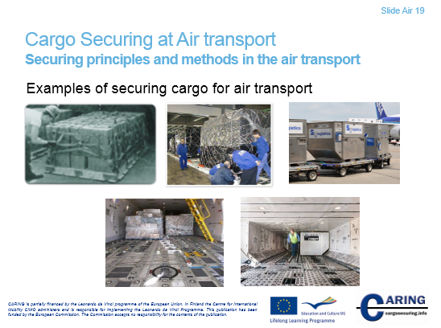
Examples of securing cargo for air transport
This slide present some examples for the cargo securing in aircraft.
The picture on top left presents cargo securing with a net. The cargo is small packages on a pallet. The picture on top in the middle presents large cargo that has been covered with plastic foil and then the cargo is secured by a net. In the picture on top and right ULDs are transported to the aircraft. At bottom ULDs have been loaded into the compartment of an aircraft.

Notes
__________________________________________________________________________________
__________________________________________________________________________________
__________________________________________________________________________________
__________________________________________________________________________________
__________________________________________________________________________________
__________________________________________________________________________________
__________________________________________________________________________________

