[Slide Rail 1]

Cargo Securing at Rail Transport

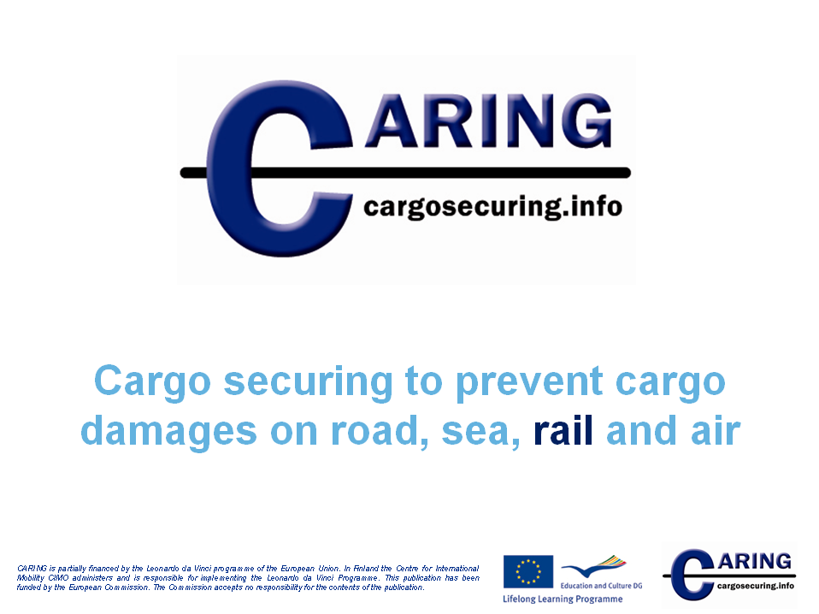

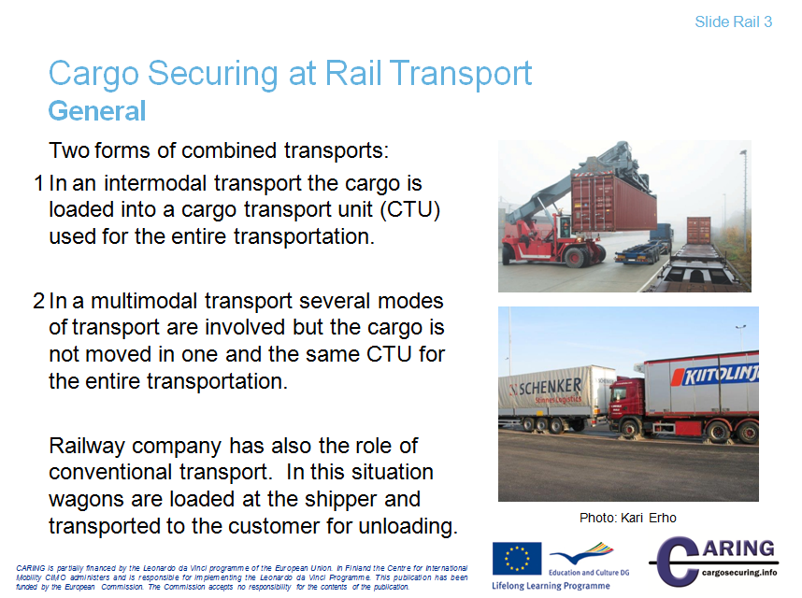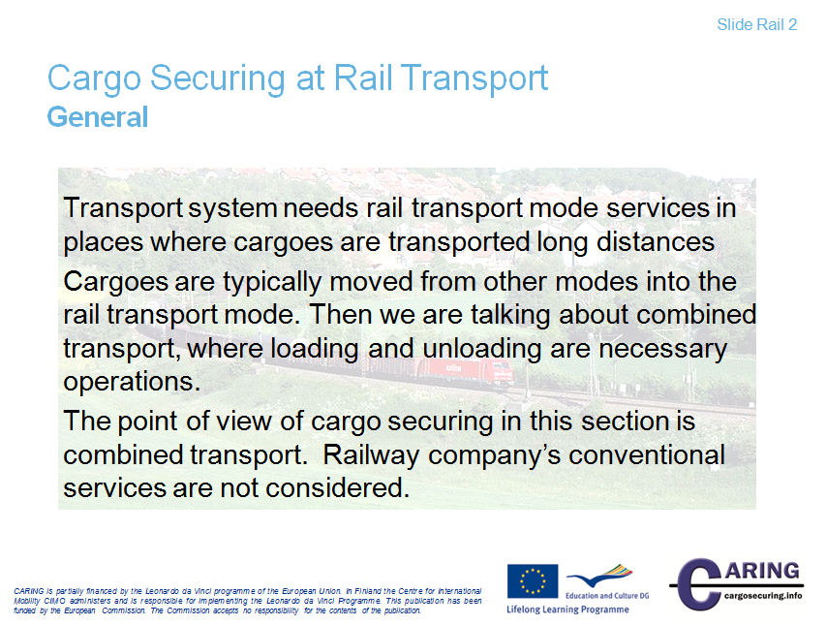[Slide Rail 2 & 3]

Introduction to rail transport
The core area of rail freight transport includes the commercial transport services with freight trains. Apart from the actual transport of goods, preparations, follow-up procedures and processes are also part in the commercial transport services.
Due to the system properties infrastructure companies are heavily involved in the production process and support the production quality.
The transport system needs the rail transport mode services in places where cargoes are transported long distances. In Central Europe, the rail freight has strong position because of the growth in container and bulk transport and the increasing importance of intermodal freight transport. In Europe (excluding CIS countries) the volume of transport was altogether 327 billion tonne-kilometers in 2010 (+7% vs. 2009).
However, the largest contribution with 3462 billion tonne-kilometers was achieved in Asia and Oceania. In worldwide the total volume of transport was 9281 billion tonne-kilometers in 2010.
The main disadvantage of rail freight is its lack of flexibility. For this reason, rail has lost much of the freight business to road transport. Many governments are now trying to encourage more freight onto trains, because of the environmental benefits that it would bring; rail transport is very energy efficient.
Intermodal transport is a subtype of multimodal transport and describes a multi-unit transport chain, where one and the same transport or loading unit is transported by at least two different modes of transport.
The term intermodality was first used in the U.S. in the 1960s. It introduced standardized containers that could be transported by rail, truck and ship.
With containerisation different modes of transport were pushed in the background and the transport chain between several modes or techniques was promoted. This produced various combinations of connections between maritime and inland waterways, road vehicles, railways, pipelines and even airplanes.
"Intermodal" means for example, that a truck is transported by rail for part of its route (piggyback transport) and the final delivery of the goods takes again place on the street.

Notes
__________________________________________________________________________________
__________________________________________________________________________________
__________________________________________________________________________________
__________________________________________________________________________________
__________________________________________________________________________________
__________________________________________________________________________________
__________________________________________________________________________________
__________________________________________________________________________________
__________________________________________________________________________________
__________________________________________________________________________________
__________________________________________________________________________________
__________________________________________________________________________________
__________________________________________________________________________________
__________________________________________________________________________________

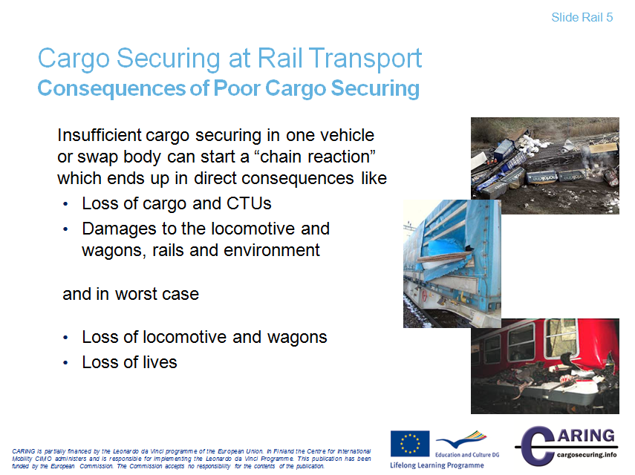[Slide Rail 4 & 5]
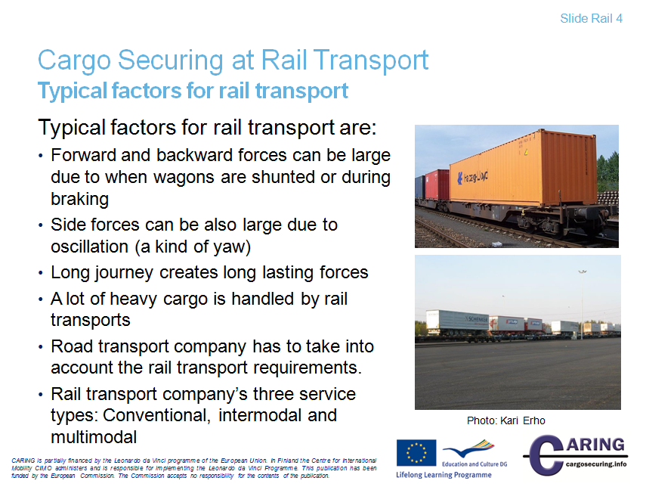

Typical factors for the rail transport
Typical factors for the rail transport are:
- Forward and backward forces can be large due to when wagons are shunted or during braking. Shunting means the operation where wagons are moved to another track.
- Side forces can be also large due to oscillation which is a kind of yaw or swing. Oscillation is composed of short transverse movements of wagons during transport. Oscillation or swinging characteristic can be observed in passenger wagon when you are travelling by train.
- Long journey can create long lasting forces
- The train is typical choice of the modes when you need to transport heavy cargo.
- The road transport company has to take into account the rail transport requirements, because there exist differences in cargo securing requirements between these modes.
- The rail transport company has three transport service types: conventional, intermodal and multimodal, in which every type have its own guidelines for cargo securing. Conventional service means that goods are loaded at the shipper and transported to the customer for unload.

Consequences of poor cargo securing
The consequences of poor or insufficient cargo securing can be divided into two main groups: direct and indirect consequences.
Direct consequences
- Loss of cargo or CTU
- Damages to locomotive, wagons, tracks and environment
and in worst case
- Loss of locomotive and wagons
- Loss of lives

Indirect consequences
- Economic consequences
- Damage to environment
- Bad will

The top picture presents an accident where a steel roll bursted through the base of a container causing huge damage. The picture in the middle shows an accident where improperly secured metal plates caused material damage to three wagons. The picture at the bottom shows an accident where tubes moved on a flat rack container and caused damage to one wagon.

Accidents may happen also in material handling phases in yards. When handling CTUs like swap bodies, trailers or vehicle the personnel working in the yard is exposed to danger due to risk of cargo breaking out. Cargo can break out because of insufficient cargo securing.

Any damage and loss creates also costs. Injuries to persons and damages to the environment cause great costs to the society, companies and of course to persons. If cargo transport units are damaged or destroyed the cargo has to be moved to other units. This creates delays and costs due to reload of cargo.

Abbreviations
CTU = Cargo Transport Unit
Reference Literature
Directive 2004/49/EC

Notes
__________________________________________________________________________________
__________________________________________________________________________________
__________________________________________________________________________________
__________________________________________________________________________________
__________________________________________________________________________________
__________________________________________________________________________________
__________________________________________________________________________________
__________________________________________________________________________________
__________________________________________________________________________________
__________________________________________________________________________________

[Slide Rail 6]
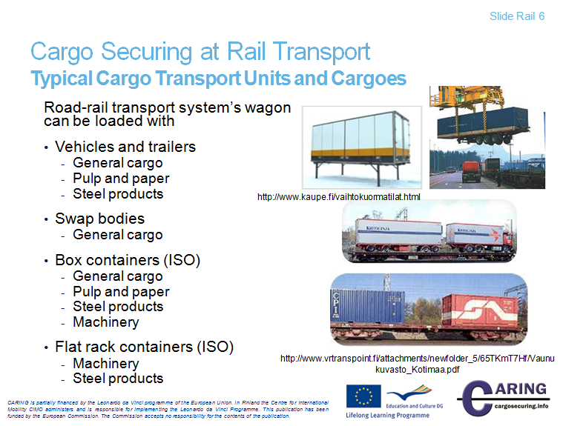

Typical Cargo Transport Units and Cargoes
Vehicles, Trailers and swap bodies
Mainly for road transport but could also be in combined transport on railway and short sea transports (non-ocean going). The superstructure of the vehicles has a great impact on the required securing arrangement.

Containers
Box and flat rack containers are very common cargo transport units for combined transport. The use of containers has made the transport logistics very efficient. The container traffic in the world has risen a lot in the last two decade.

In the next slides containers, swap bodies are considered in more detail.

Typical Cargo
- General cargo: Chemicals
- Pulp and paper: paper reel, sheeted paper pallets, pulp bales
- Steel products: steel bars, slabs, coils, pipes etc.
- Machinery: Turning machines, grinding machines etc.
- Vehicles: Cars, trucks, Construction equipment etc.
- Project cargo: Cranes, Heavy forklifts, wind mills, rock drills etc.

Notes
__________________________________________________________________________________
__________________________________________________________________________________
__________________________________________________________________________________
__________________________________________________________________________________
__________________________________________________________________________________
__________________________________________________________________________________
__________________________________________________________________________________
__________________________________________________________________________________
__________________________________________________________________________________
__________________________________________________________________________________

[Slide Rail 7]

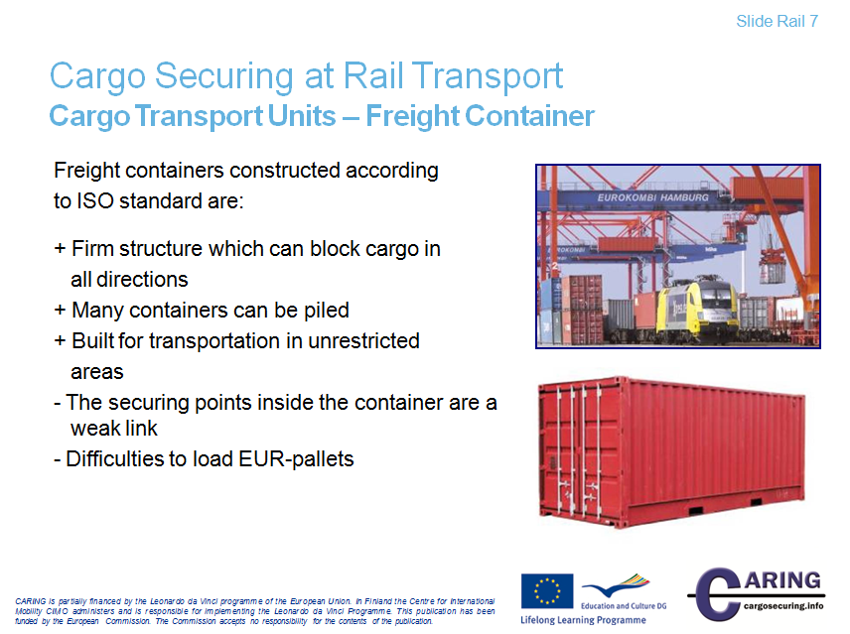

Cargo Transport Units - Freight Container
If the container is designed according to the ISO‐standard 1496‐1 the cargo can be evenly blocked against the sides and end walls of the container.

A disadvantage with a freight container is that the size of a EUR‐pallet 1200 x 800 mm doesn’t fit well to the internal dimensions of the ISO container e.g. 20 ft container with inner dimension 5867 x 2330 mm. This fact leads to loading patterns with a lot of void spaces to take care of when securing the cargo.

When lashings are used to secure the cargo inside a container one has to consider that requirements on the lashing points in a ISO‐container is comparatively low and the securing points become the “weak link” in the securing arrangement.

According to the ISO standard the lashing points can be a “weak link”;
‐ For general purpose containers, cargo securing devices are optional
- Anchor points shall be designed and installed to provide a minimum safe load of 1000 kg, applied in
any direction
‐ Lashing points shall be designed and installed to provide a minimum safe load of 500 kg, applied in
any direction

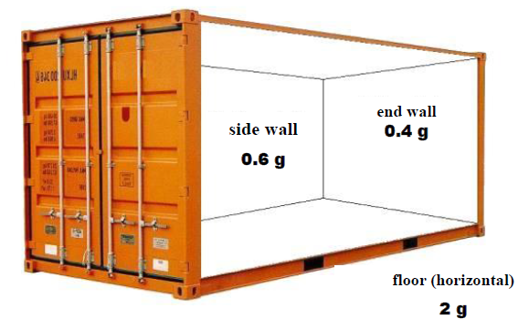
Source: Marc Wiltzius–Fastening expert www.arrimage-charges.com presentation in http://www.uic.org/
Notes
__________________________________________________________________________________
__________________________________________________________________________________
__________________________________________________________________________________
__________________________________________________________________________________
__________________________________________________________________________________
__________________________________________________________________________________
__________________________________________________________________________________
__________________________________________________________________________________
__________________________________________________________________________________
__________________________________________________________________________________

[Slide Rail 8]
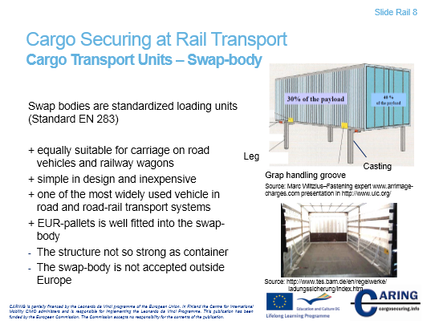
Cargo Transport Units – Swap body
Swap bodies are standardised loading units equally suitable for carriage on road vehicles or railway wagons. In northern countries swap bodies are used only in road transport. In the middle of Europe swap body is widely used in road-rail transport system. As they can be used in a broad range of situations, are simple in design and inexpensive, this form of conveyance has been highly successful and is currently one of the most widely used transport systems on the market.

The swap body is not so popular on sea transport as it needs a roll trailer or equal to stand on. They have an effect on the filling rate of the ships. (Nils Andersson, Mariterm Ab)

Source: UIC “Safe loading” seminar Paris, 12 October 2011 http://www.uic.org/

Notes
__________________________________________________________________________________
__________________________________________________________________________________
__________________________________________________________________________________
__________________________________________________________________________________
__________________________________________________________________________________
__________________________________________________________________________________
__________________________________________________________________________________

[Slide Rail 9]

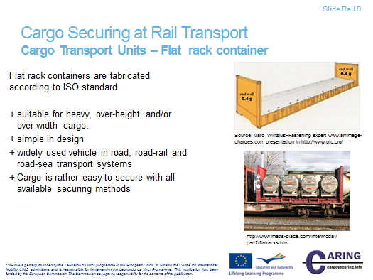

Cargo Transport Units – Flat rack container
Flat racks are best suited for stowage of heavy lift, over-height and/or over-width cargo. Flat racks have collapsible end frames and without roof and sidewalls. Lashing rings on the bottom side rails, corner posts and floor are available to enable cargo to be secure using straps or chains. If a rack with end walls should be handled in a normal way in the container transport system it requires the end walls to withstand the same forces as for a general freight container.
The flat rack is usually manufactured within the frame of the ISO-standard and mainly with a length of 20 or 40 ft.
The flat rack “tare” weight is the same or somewhat higher than the corresponding tare for a general freight container. A normal 20 ft. platform with end walls has MGW (Maximum Gross Weight) 24 000 kg and a tare weight of approx. 2 500 kg, consequently a payload of approx. 21 500 kg. A normal 40 ft. platform with end walls has MGW 30 480 kg and a tare weight of approx. 5 000 kg, consequently a payload of approx. 25 500 kg.
A flat rack with end walls gives better protection to the cargo than a platform without end walls, at the same time the possibility to secure the cargo increases. Flat racks with end walls can be stacked in terminals and on board ships without any stress on the cargo.
A flat rack with end walls uses less volume when transported empty and therefore some platforms are equipped with collapsible end walls.
The internal height of a platform-based container with MGW according to the ISO-standard is often less than the height mentioned in the standard for a freight container. With the internal height means the distance between the floor and the upper edge of the upper corner fittings. You should not use the total internal height since a container or flat rack stacked on top of the platform-based container can sag and destroy the cargo.
The height of the platform floor has to be approx. 600 mm to carry the loads from the cargo, which means that the internal height is significantly lower than for a general container. In some cases the internal length can also be considerably shorter than for a general container as the end walls have to be made strong to withstand the designing forces.

Notes
__________________________________________________________________________________
__________________________________________________________________________________
__________________________________________________________________________________
__________________________________________________________________________________
__________________________________________________________________________________
__________________________________________________________________________________
__________________________________________________________________________________
__________________________________________________________________________________
__________________________________________________________________________________
__________________________________________________________________________________

[Slide Rail 10]
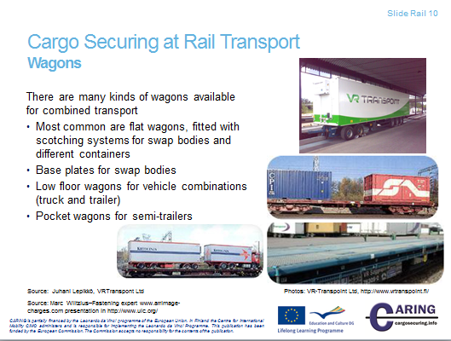

Wagons
There are different kinds of wagons available for combined transport purposes. Those most commonly used for rail-road combined transport are flat wagons, fitted with scotching systems for swap bodies and containers, as well as base plates for swap bodies
Wagons used to carry semi-trailers have very low floors and recesses (or pockets) to accommodate the wheels.
Sources:
UIC “Safe loading” seminar Paris, 12 October 2011 http://www.uic.org/
Juhani Lepikkö, VR-Transpoint Oy, Finland

Notes
__________________________________________________________________________________
__________________________________________________________________________________
__________________________________________________________________________________
__________________________________________________________________________________
__________________________________________________________________________________
__________________________________________________________________________________

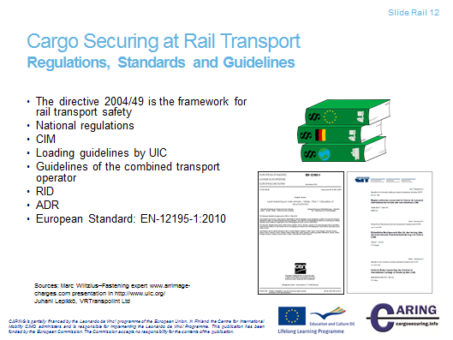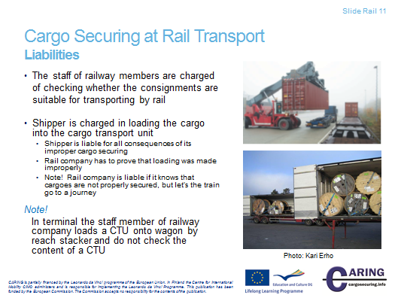[Slide Rail 11 & 12]

Liabilities
The cargo securing is the necessary act in transport modes, because every transport is to be made safely protecting environment, human lives and stakeholders’ any kind of properties. That’s why countries have set legal acts, standards and norms for the cargo securing.
Shipper is charged in loading the cargo into the cargo transport unit and therefore is liable for all consequences of its improper cargo securing. However, if something unfortunate happens, the rail company has to prove that loading was made improperly. Rail company is liable if it knows that cargoes are not properly secured, but let’s the train go to a journey.
In terminal the staff member of Railway Company loads a CTU onto a wagon by reach stacker. The a person will check that the CTU has been properly fastened to the wagon.

Regulations, Standards and Guidelines
The directive 2004/49
The directive 2004/49 given by the European Parliament is the framework for rail transport safety. The purpose of the directive is to develop the overall safety of the rail transport and to improve the access to the markets of railway services. The directive defines also common safety objectives. The directive implies that member states will establish a safety authority and government to investigate accidents. In addition, the directive gives principles to safety management. The directive does not give any instructions to cargo securing.

National regulations
Acts and degrees regulate efficiently a nation’s rail transport. Nations in Europe have for instance railway acts and decrees. Railway acts determines overall safety matters and decrees give more detail instructions for cargo securing and loading as well as making packages for transport. In addition, responsibilities for different parties are determined.
Uniform Rules Concerning the Contract of International Carriage of Goods by Rail (CIM)
These Uniform Rules are applied to every contract of transport of goods by rail for reward when the loading place and the unloading place are situated in two different Member States. These rules are applied also to the situation of two states where one is a Member State and the parties to the contract agree that the contract is subject to CIM rules.
Articles from 6 to 12 consider the content of the contract of transport and make a reference to dangerous goods, the transport of which has to make according to RID-rules. The RID is clarified below. The article 11 consists of examination procedure in which the carrier has the right to examine at any time whether the conditions of carriage have been complied with and whether the consignment corresponds with the entries in the consignment note made by the consignor.
The section 1 of the article 13 determines the responsibilities for loading and unloading of the goods. The paragraph 2 says that the consignor is liable for all the consequences of defective loading carried out by him. He must compensate the carrier for the damage sustained. However, the burden of proof of defective loading lies with the carrier. Articles 23, 24 and 25 consider liabilities in more detail.

Loading guidelines by UIC
International Union of Railways has published technical report of loading guidelines. Guidelines consist of guidelines principles and many supplements to the principles section. National loading instructions follow these guidelines.

Regulations concerning the International Carriage of Dangerous Goods by Rail (RID) (Ordnung für die Internationale Eisenbahnbeförderung gefährlicher Güter)
This regulation applies to the international carriage of dangerous goods by rail on the territory of the RID Contract States. The RID regulations specify in detail the authorized transport with regard to classification of goods, use of packaging, use of tanks, consignment procedures and the use of means of transport.

European Agreement concerning the international carriage of Dangerous goods by Road (ADR)
ADR-agreement regulates international road transports of dangerous goods. The agreement determines the liabilities for different parties during the transport process as well as selection of correct vehicle and equipment. In addition, instructions for the transport operation will be given. Also the agreement considers packaging of goods and their labeling.
The agreement is quite short itself, but it has two vast annexes. The first annex describes different dangerous goods and gives instructions for packaging and labeling. The second annex considers the conditions as regard with construction, equipment and operation of the vehicle carrying the goods in question.
It is good to notice that in RID it is said that for combined transports the road rules (ADR) are sufficient. Also, in the ADR the standard EN 12195-1 will be sufficient from the 1st of July 2013.
Guidelines of the combined transport operator
The railway transport operators act today more and more as combined transport operators. Accordingly, operators have made loading instructions for cargo transport units that are carried in multimodal system.

Sources:
The directive 2004/49, http://eur-lex.europa.eu/LexUriServ/LexUriServ.do?uri=CELEX:32004L0049
UIC, http://www.uic.org
Nils Andersson, MariTerm Ab
Juhani Lepikkö, VR-Transpoint Oy

Notes
__________________________________________________________________________________
__________________________________________________________________________________
__________________________________________________________________________________
__________________________________________________________________________________
__________________________________________________________________________________
__________________________________________________________________________________
__________________________________________________________________________________
__________________________________________________________________________________
__________________________________________________________________________________
__________________________________________________________________________________
__________________________________________________________________________________
__________________________________________________________________________________
__________________________________________________________________________________
__________________________________________________________________________________

[Slide Rail 13]

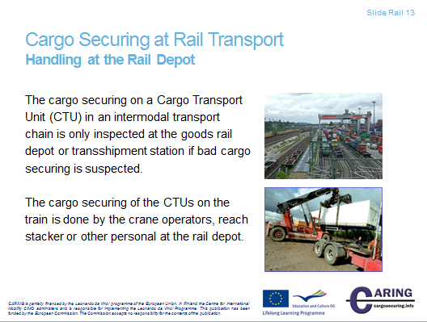

Handling at the Rail Depot
The rail depot or a transshipment location is the place, where cargo transport units arrive and are loaded onto wagons. The depot has a large hump yard, where a train is assembled. The cargo securing focuses on fastening the cargo transport unit onto the wagon. The content of the CTU keeps untouched.

The cargo securing on a CTU in an intermodal transport chain is inspected at the goods rail depot or transshipment station only, if bad cargo securing is suspected.

See also the next two pages describing the acting forces, in which shunting operation is described.

The gantry crane spans his work area like a porch. It runs mostly on two parallel rails on which it rests with its supports. Thus, it differs from a bridge crane that runs on elevated tracks. The portal is a steel frame, which is usually performed in truss or frame construction. The crane has a respective hinged support and a rigid support, in order to compensate the temperature-induced change in length of the crane bridge (horizontal portion of the portal). Along the crane bridge moves the trolley with hoist. But it can also be mounted on a rail crane, the crane bridge. The rails can be installed free or sunk into the grounds.
Reach stacker is a kind of fork lift trucks that are used for stacking and handling of containers and swap bodies, especially in combined transport. These are heavy wheeled vehicles up to 50 tons lifting capacity to 100 tons tare.
Unlike conventional forklifts the spreader (lifting device) in reach-stackers, are not mounted on a mast, but at the end of an oblique arm similar to a telescopic crane. The reach stacker reaches the cargo units from above, if necessary across different containers. Modern vehicles so far can reach out two container widths and container piled up in the third row. They can also grab across a track and transfer a container from one train to another in the adjacent track. A conventional truck would have to cross the tracks with each container.

Notes
__________________________________________________________________________________
__________________________________________________________________________________
__________________________________________________________________________________
__________________________________________________________________________________
__________________________________________________________________________________
__________________________________________________________________________________
__________________________________________________________________________________
__________________________________________________________________________________
__________________________________________________________________________________
__________________________________________________________________________________

[Slide Rail 14 & 15]

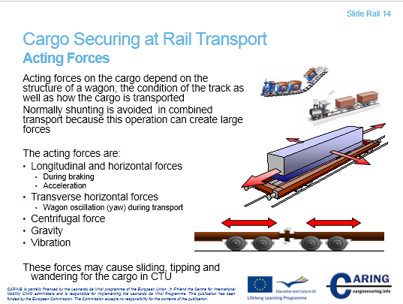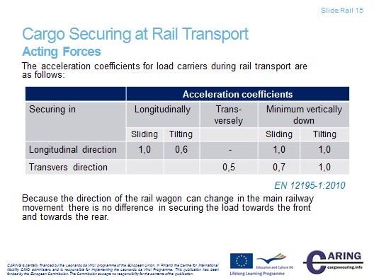

Acting forces
Forces that exist during rail transport depend on the structure of a wagon and the way cargo is loaded as well as cargo is transported.
Shunting is an everyday operation in rail transport system. Shunting means the operation in the hump yards, where single railway wagons or groups of wagons are pushed to run against each other and be coupled together. A hump yard has normally a low slope so that wagons can run down the hump. If there is no hump yard, wagons are kicked by switching engines and the individual wagons run into the appropriate sorting sidings.
Shunting creates large acceleration to wagons and to cargo within wagons. Acceleration can be value 4 g. CTUs are not constructed to stand such kind of stress. In combined transport the shunting is avoided by a special switching engine or wagons have special buffers that absorb shocks. In combined transport the shunting is avoided also by making block trains that run from the departure station to the destination station without any switching.
The acting forces in rail transport are:
- Longitudinal and horizontal forces during braking, acceleration and switching operation
- Transverse horizontal forces created by wagon oscillation that is a kind of yaw
- Centrifugal force
- Gravity
- Vibration
These forces may cause sliding, tipping and wandering for the cargo in CTU.
In road transport forces act on the cargo due to breaking, driving in curves and accelerating. Vibration is caused by the CTU’s engine, tires and suspension. Also road surface contributes to the amplitude of vibration and may cause fast and strong shocks. These forces try to move cargo from its place on the cargo platform.
Note: Acting forces can be illustrated with different natural examples. The one is to use the passenger car.

The acceleration coefficients for load carriers during rail transport are shown in the table (slide 15).
Because the direction of the rail wagon can change in the main railway movement there is no difference in securing the load towards the front and towards the rear.
Note that in the column of ”Minimum vertically down” there is a dynamic variation downwards (and actually to upwards) – 0,3 g.
This table is in the standard EN 12195-1:2010.

Notes
__________________________________________________________________________________
__________________________________________________________________________________
__________________________________________________________________________________
__________________________________________________________________________________
__________________________________________________________________________________
__________________________________________________________________________________
__________________________________________________________________________________
__________________________________________________________________________________
__________________________________________________________________________________
__________________________________________________________________________________

[Slide Rail 16]
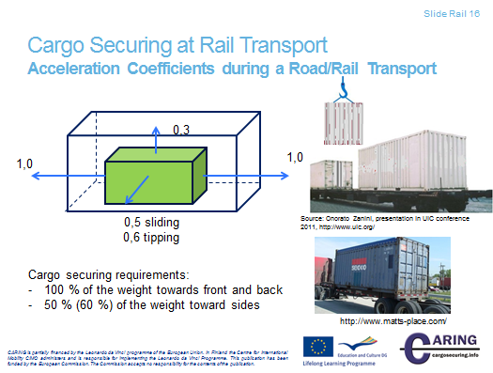
Acceleration coefficients during a Road/Rail Transport
In this slide we can see that the cargo inside a CTU has the accelerations towards front and back 1 g and vertically upwards 0,3 (dynamic variation). In sideways the cargo have same acceleration values as in road transport.

Notes
__________________________________________________________________________________
__________________________________________________________________________________
__________________________________________________________________________________
__________________________________________________________________________________
__________________________________________________________________________________
__________________________________________________________________________________
__________________________________________________________________________________
__________________________________________________________________________________
__________________________________________________________________________________
__________________________________________________________________________________

[Slide Rail 17]
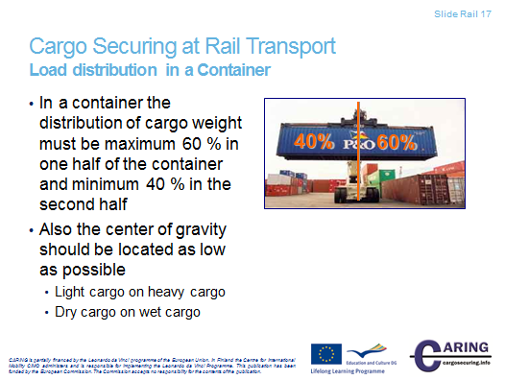
Load distribution in a container
In a container the distribution of cargo weight must be maximum 60 % in one half of the container and minimum 40 % in the second half
Also the center of gravity should be located as low as possible. Basic loading rules are:
Light cargo on heavy cargo
Dry cargo on wet cargo

Notes
__________________________________________________________________________________
__________________________________________________________________________________
__________________________________________________________________________________
__________________________________________________________________________________
__________________________________________________________________________________
__________________________________________________________________________________

[Slide Rail 18]

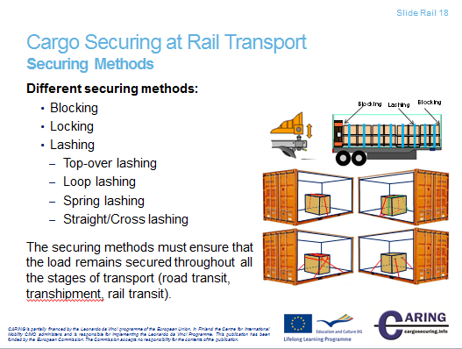
Securing in CTUs - Securing Methods
The picture shows different securing methods. The basic method is blocking with or without any securing devices. When the blocking is not enough to prevent the cargo from sliding and tipping the next step is to either complement the blocking with lashing or secure with lashing only.

Locking
A typical way of locking the load is locking freight containers to the vehicle, wagon or seagoing vessel by twist‐locks.

Blocking
Blocking against parts of the vehicle signifies that the load is placed in close contact with the headboard or the sideboards. If the transport contains several cargo units they must be packed close together as possible. Void spaces can occur, due to the shape of the goods and these should be filled out with pallets, dunnage bags etc.

Blocking is first of all a method to prevent cargo from sliding, but if the blocking reaches up to or above the cargo’s centre of gravity it is also prevents tipping. Blocking should be used as far as possible.

Top-over lashing
In the standard EN 12195‐1 top‐over lashing is mentioned as friction lashing. The top‐over lashing is placed over the cargo and the purpose is to raise the pressure between the cargo and the platform to increase the force of friction. This is excellent as a securing method, but has an important limitation. The lashing is most efficient if the angle between the loading platform and the lashing is 90°. If the angle diminishes the lashing loses in effect. The values in the Quick Lashing Guide are valid for angles between 75‐90°. At angles between 30‐75° the number of lashing must be double. If the angle is under 30° another lashing method should be chosen.
The positioning of the lashing is critical too, primarily for the possibility to prevent tipping forwards/backwards. When a lashing is used it must be placed over the centre of the load.

Loop lashing
A pair of loop‐lashings prevents the cargo from sliding and tipping sideways. Minimum one pair of loop lashings per section should be used. When long cargo sections are secured with loop lashings at least two pair of loop lashing should be used to prevent the cargo twisting.

Spring lashing
A spring lashing is mainly used to prevent cargo from sliding and tipping in the forward or backward direction and can solve many loading problems, in particular when cargo is loaded in a second not blocked layer. Often the load in the upper layer must be placed away from the headboard in order not to exceed the limits of axle pressure. A spring lashing is then a good solution.

A spring lashing can be made in various manners, but common is that the angle between the lashing and the platform bed should be as low as possible. A spring lashing rapidly loses its effect when the angle is greater. The tables in the pocket guide are valid for an angle of maximum 45°.

Straight lashing (cross lashing)
In the standard EN 12195‐1 straight lashing is mentioned under the section direct lashing as slope or diagonal lashing. This type of lashing is used primarily on larger machinery and cargo where you can attach the lashing directly to the cargo. A straight lashing prevents both sliding and tipping. Depending on the angle between the securing point on the cargo and the securing point on the platform, the effect to prevent tipping is different to that of sliding.

Notes
__________________________________________________________________________________
__________________________________________________________________________________
__________________________________________________________________________________
__________________________________________________________________________________
__________________________________________________________________________________
__________________________________________________________________________________
__________________________________________________________________________________
__________________________________________________________________________________

[Slide Rail 19]
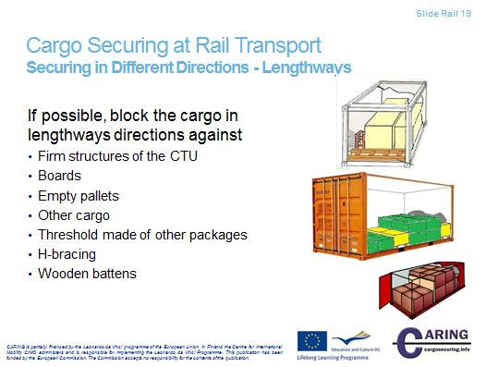
Securing in Different Directions - Lengthways
Blocking is the primary method of cargo securing. It can be used in cooperation with a wide variety of devices. It eliminates the movement of the cargo so that sliding or tipping can’t occur. End walls can be used - if they are strong enough. Note however, the strength requirements in the ISO container standard is 0.4 x Payload on end walls. But combined transport operators use acting forces that can be up to 0,8 x payload. It seems that everybody has accepted this blocking stress.

If there is void space between end wall and cargo, dunnage wood devices can be used to make proper cargo securing. Other possible blocking ways are: other cargo and threshold made of other packages.

The blocking can be arranged by:
‐ Firm structures of the CTU e.g. support from headboard, drop sides, container end walls etc.
Note: some countries require that the strength of superstructure is guaranteed by a certificate from the manufacturer
‐ Boards
‐ Empty pallets
‐ Other cargo
‐ Threshold made of other packages
‐ H‐bracing
‐ Wooden battens

Notes
__________________________________________________________________________________
__________________________________________________________________________________
__________________________________________________________________________________
__________________________________________________________________________________
__________________________________________________________________________________
__________________________________________________________________________________
__________________________________________________________________________________
__________________________________________________________________________________
__________________________________________________________________________________
__________________________________________________________________________________

[Slide Rail 20]
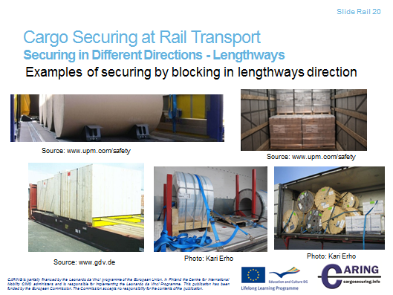

Securing in Different Directions - Lengthways
Examples of securing by blocking in lengthways direction
- Blocking by bars
- Blocking by H-braces
- Blocking by empty pallets
- Blocking by wooden battens (H-brace)
- Blocking by the cargo itself

Notes
__________________________________________________________________________________
__________________________________________________________________________________
__________________________________________________________________________________
__________________________________________________________________________________
__________________________________________________________________________________
__________________________________________________________________________________
__________________________________________________________________________________
__________________________________________________________________________________
__________________________________________________________________________________

[Slide Rail 21]
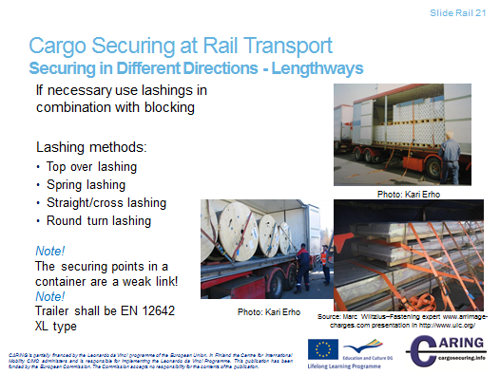

Securing in Different Directions - Lengthways

If blocking cannot be sufficiently arranged, the cargo can be secured by complementary lashings or by lashings only.
Top-over lashings
The top-over lashings run from side to side over the load. The top-over lashing is most efficient if the angle between the loading platform and the upright part of the lashing is close to 90°. To prevent longitudinal tipping, the lashings should be placed symmetrically.
In the left picture top-over lashing is used in combination with blocking.
Spring lashing
A spring lashing is used to block the load in the forward or backward direction and can solve many loading problems. See the picture at the bottom. Here spring lashing has been formed with two webbings that are fastened through the legs of the pallets. The top-over lashing press the metal sheet packages downwards.
Spring lashing can be used in containers to prevent from sliding forwards or backwards, but remember that lashing points are the weak link; normally they withstand only 0,5 tons weight.
In the Quick Lashing Guides, the number of lashings is calculated for an angle between the platform and spring lashing of maximum 45°.

Straight lashing – Cross lashing
This type of lashing is used primarily on larger machineries and cargoes where the lashing can be attached directly to the cargo. This lashing can prevent both sliding and tipping. Depending on the angle between the attachment point on the cargo and the attachment point on the floor, the effect to prevent tipping is different to that of sliding. If the lashings are put crossways (cross lashing) it is of utmost importance that the cross is located over the centre of gravity of the cargo - otherwise the lashings may help the cargo to tip over. In the Quick Lashing Guides, the number of lashings is calculated for horizontal and vertical angles between 30° and 60°.
Round turn lashing
Round turn lashing with blocking can be used for securing paper rolls.

Notes
__________________________________________________________________________________
__________________________________________________________________________________
__________________________________________________________________________________
__________________________________________________________________________________
__________________________________________________________________________________
__________________________________________________________________________________
__________________________________________________________________________________
__________________________________________________________________________________
__________________________________________________________________________________
__________________________________________________________________________________

[Slide Rail 22]
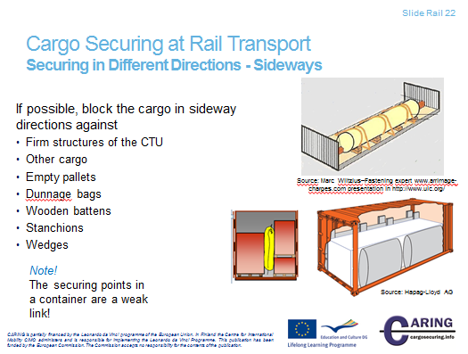

Securing in Different Directions - Sideways
The possibility to block cargo sideways is depending on the strength of the superstructure of the cargo transport unit. If the void space is too large, depending on national regulations, it can be filled out by
- Other cargo
- Empty pallets
- Dunnage bags (air bags) or other suitable means.
- Wooden battens
- Stanchions
- The cargo can alternatively also be supported by vertical bars for limited weights.

Blocking against parts of the CTU
Blocking against parts of the CTU signifies that the load is placed in close contact with the headboard, sideboards or walls. Where cargo of regular shape and size is loaded, a tight stow from wall to wall should be sought. However, in many instances some void space may occur. If the space between the packages is too large, then the stow should be secured by using empty pallets, dunnage, folded cardboard, air bags or other suitable materials. All unnecessary empty spaces must be avoided and that becomes more important with increased weight.

Blocking by timber chocking
The load must at times, due to its form or weight, be placed in a position on the platform away from the headboard, sideboard or walls. Then a construction of timber chocking and nailed battens can be used to prevent the load from sliding. For road transports the dimensions and number of the battens are to be estimated to bear the whole weight forward, half the weight backwards and to the sides.
Examples:
The picture at the top: Rolls on the flat container can be secured sideways by loop lashing. Flat rack containers need also wooden structures.
The picture at the bottom: The crates are chocked against the side walls with large bearing areas, on the left with dunnage, on the right with air bags.

Notes
__________________________________________________________________________________
__________________________________________________________________________________
__________________________________________________________________________________
__________________________________________________________________________________
__________________________________________________________________________________
__________________________________________________________________________________
__________________________________________________________________________________
__________________________________________________________________________________
__________________________________________________________________________________
__________________________________________________________________________________

[Slide Rail 23]
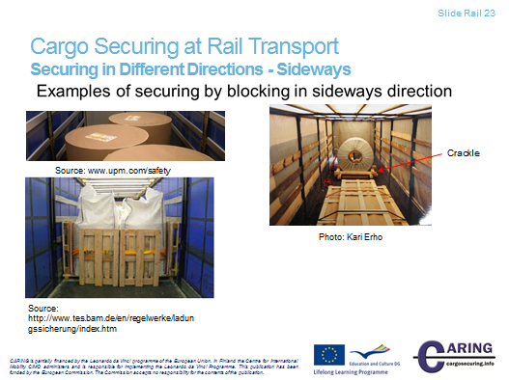
Securing in Different Directions - Sideways
In this slide only a few examples of securing by blocking in sideways direction will be shown.

Where cargo of regular shape and size is loaded, a tight stow from wall to wall should be sought. In many situation the tight stow will not be achieved. This is due to heavy or large cargo units.

In many instances some void space may occur. This void space can be filled with empty pallets. The picture at the bottom shows the use of empty pallets to make tight stow. The palletized big bags have been loaded to a cover/stake trailer (standard EN 12642 L). The cargo has been rounded with pallets and also lashed with one webbing (round turn lashing). The pallets are against side walls.

In the left picture on top paper rolls have been loaded in zigzag manner into a cover/stake trailer. The rolls can be block against sidewalls if the trailer is built according to standards EN 12642 XL. Note that here it is not necessary fill the void space, because rolls make a tight stow. Here you save also unnecessary weight, which result in situation where a lot of void space occur and many empty pallets are needed to fill that space.

Blocking using devices
In the picture right a crackle is used to block cargo sideways. Typically heavy cargo is blocked sideways by this way. The blocking device can be also a CTU’s pocket in the platform.

Other examples of securing by blocking in sideways direction are for instance:
Blocking by other cargo
Blocking by other cargo
Blocking by dunnage bag
Blocking by wooden battens
Blocking by empty pallets
Blocking by wooden battens

Notes

__________________________________________________________________________________

__________________________________________________________________________________

__________________________________________________________________________________

__________________________________________________________________________________

__________________________________________________________________________________

__________________________________________________________________________________

__________________________________________________________________________________

__________________________________________________________________________________

__________________________________________________________________________________

[Slide Rail 24]
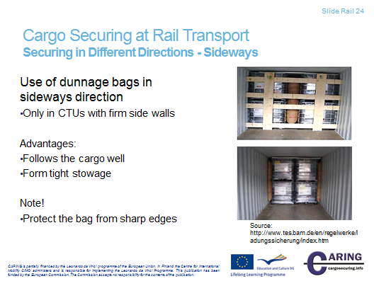

Securing in Different Directions - Sideways
Dunnage woods can be used in many ways to protect cargo sliding sideways. The air pressure must not be more than recommended by the manufacturer. The advantages of the dunnage bag are:
- follow the cargo well
- form tight stowage

Notes

__________________________________________________________________________________

__________________________________________________________________________________

__________________________________________________________________________________

__________________________________________________________________________________

__________________________________________________________________________________

__________________________________________________________________________________

__________________________________________________________________________________

__________________________________________________________________________________

__________________________________________________________________________________

[Slide Rail 25]

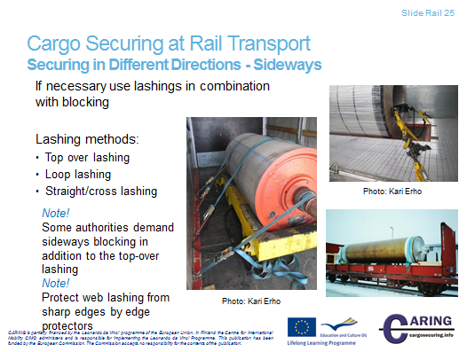

Securing in different directions - sideways
If blocking cannot be sufficiently arranged, the cargo can be secured by complementary lashings or by lashings only.

Top-over lashings
The top-over lashings run from side to side over the load. The top-over lashing is most efficient if the angle between the loading platform and the upright part of the lashing is close to 90°. For instance long pipes can be secured with top-over lashing with webbings. Also many times over-width cargo is secured by top-over lashing.

Note!
Some authorities demand sideways blocking in addition to the top-over lashing. The picture on the left shows the situation where the cargo has been blocked with a crackle.

Loop lashing
A Loop lashing is not just a single lashing. They are used in pairs to be effective – one loop around the load from each side of the platform – and they are very effective to prevent sliding and tipping. Furthermore, they must be accompanied by securing in the forward/backward directions. Each cargo section must be secured with at least two pairs of lashings in order to not twist. If the different cargo sections are supporting each other and thereby stop twisting, only one loop lashing may be needed per section of cargo. A good example is a lying coil that is shown in the picture at bottom.

Straight lashing – Cross lashing
This type of lashing is used primarily on larger machineries and cargoes where the lashing can be attached directly to the cargo. This lashing can prevent both sliding and tipping.

Note!
Protect web lashing from sharp edges by edge.

Notes

__________________________________________________________________________________

__________________________________________________________________________________

__________________________________________________________________________________

__________________________________________________________________________________

__________________________________________________________________________________

__________________________________________________________________________________

__________________________________________________________________________________

__________________________________________________________________________________

__________________________________________________________________________________

[Slide Rail 26 & 27]
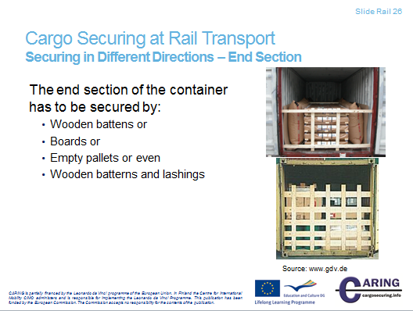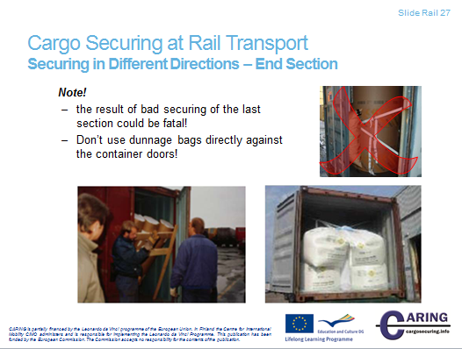
Securing in Different Directions - End Section
The end section in a container load has to be secured by
‐ Wooden battens or
‐ Boards or
‐ Empty pallets

All personnel unloading the cargo are exposed to danger if the cargo has shifted in the CTU during the transport. This is in fact the most common reason for injuries, sometimes fatal, caused by insufficient cargo securing. When loading, all packages have to be secured in such a way that they don´t fall off the CTU when the doors are opened.

Note – Don’t use dunnage bags directly against the container doors! Use wooden battens or place the dunnage bags between the last and the second last section.

Notes
__________________________________________________________________________________
__________________________________________________________________________________
__________________________________________________________________________________
__________________________________________________________________________________
__________________________________________________________________________________
__________________________________________________________________________________
__________________________________________________________________________________

[Slide Rail 28]
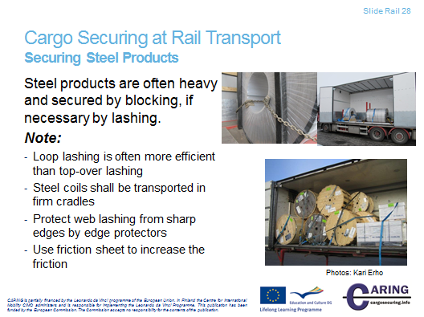
Securing Steel Products
Steel coils
Coils, steel or other metals, can be transported laying on the end or standing on the roll. Contrarily to paper reels, coils transported on the roll are called “standing” and coils transported on the ends are called “lying”. However, this may differ between steelworks depending on the widths and diameters of the produced coils.
Lying coils
The coils should be placed close together on a surface with a high coefficient of friction. Depending on the number of coils and their sizes, it may be necessary to place them in groups on the CTU to obtain good weight distribution.
The coils should be bottom blocked and secured by top-over lashings with heavy edge protectors. It may be necessary to attach spring lashings in both travelling directions.
If the cargo is placed in groups, each group should be individually secured.
Standing coils
Narrow standing coils
Due to the weight distribution, the coils are spread out on the platform. Many coils are transported completely covered with closed centre cores. To be able to secure coils with closed cores efficiently, they should be placed with the axes along the CTU.
Longitudinal dunnage at the bottom of the coils prevents sliding forwards and backwards both at braking and shunting. Long battens on top of the coils secured by loop lashings prevent tipping longitudinally.
One pair of loop lashings per coil secured to the sides of the CTU prevents the coils from sliding or rolling transversally. The loop lashings are designed for the stress that may occur during the transportation. This means that the strongest lashings are required at sea transport in area C. Also in the rail transport the stress is equal for both directions.
Wide standing coils
Wide standing coils can be loaded and secured in the same way as narrow coils. Since wide coils are often heavy, the longitudinal distance between them can be large. To minimise the risk of cracking the blocking battens, the top as well as the bottom batten is supported to the platform floor. The horizontal battens and the supports should be nailed to the floor of the CTU. Double pairs of loop lashings may be required to secure the coils transversally.
Standing coils with open cores
Standing coils with open cores can be loaded and secured according to the same principles as for coils with closed cores.
In general, lashings applied through the centre of the coils should be performed with chain or wire. Web lashings are easily damaged by the sharp steel edges and should be avoided or carefully protected.
Rod wire
Rod wire is mostly transported in coils, packed to large units of 4-6 wire coils in each. Even if the coils may seem rigid during loading, they may act like living snakes during transport. The coils should if possible be placed in rows with the centre axis longitudinally to the load carrier. The different rows are lashed together in sections. One loop lashing is used from each side of the section, secured to the platform bed on each side and through the centre of the opposite coil.
Rod wire is often loaded by forklifts equipped with a pole. Loading to trailers is often performed from the side demanding another cargo securing method. The rod wire can be loaded in individual heaps to meet the weight distribution required in the trailer. To prevent movements forwards and backwards, battens are nailed in front of and behind each section of the rod wire. The sections are lashed together and secured to the cargo transport unit. The best way to prevent the wire coils from tipping sideways is to use centre stanchions.

The rod wire can also be spread into two rows on the platform. In this case, blocking battens are placed along the sides of the wire coils. Loop lashings are attached to either side to prevent tipping sideways. At the rear end a bar or wedge is placed.
If the weight capacity and width of the trailer admit, the number of coils can be increased to three in some of the sections. In some cases the coils are too wide to be loaded three per cross section. In this case some coils are loaded in an upper layer. These coils are carefully secured to the coils in the bottom layer. At sections with two layers, the loop lashings are attached to the coils in the upper layer as extra support.
In containers the rod wire is loaded with forklift trucks equipped with a pole. The coils can often be loaded in two rows in the container. If a 20ft container is used, the cargo often covers the container floor and the only securing required is to prevent the coils from leaning towards the doors.
A 40ft container has a larger volume/weight capacity ratio than a 20ft container. Thus void space occurs which cannot be used. An alternative loading pattern that fills the entire length of the container is a load of single and double rows.
The single loaded coils can be secured sideways by a lashing of for example heavy steel straps or wire applied through the centre hole of the coils. If a single coil is loaded in the front of the container or at the end doors, the lashing is applied around a firm bar in order to secure also the coils at the ends. The lashing also prevents the coils from leaning towards the doors.
Metal and steel bars
To secure bars they must be sorted due to length and blocked by firm H-braces both forwards and backwards. Loop lashings can be used to reduce the pressure from the cylindrical bars onto the sideboards. If square-shaped slabs are transported with cylindrical bars the best placement for the square-shaped bars is close to the sideboards.
Steel sheets
Steel sheets are a large transport commodity and demands quite a lot of cargo securing since the friction is rather low and the weight is considerable.
To make sure that the steel sheets can stand the longitudinal forces which may occur at braking and shunting accelerations, stable blocking like H-braces or spring lashings of wire or chain backwards and forwards are needed.
The sideways blocking is done by wire or chain loop lashings. If the plates are wider than the CTU, straight ( cross ) lashings may be used. If only top-over lashings are used, the number of lashings must be increased.

Quite a lot of special steel sheets are transported in racks and boxes. For these transports friction sheets combined with loop lashings can be used with a good result for securing against transverse forces. The longitudinal forces at shunting and braking are absorbed by braces.

Notes

__________________________________________________________________________________

__________________________________________________________________________________

__________________________________________________________________________________

__________________________________________________________________________________

__________________________________________________________________________________

__________________________________________________________________________________

__________________________________________________________________________________

__________________________________________________________________________________

[Slide Rail 29]
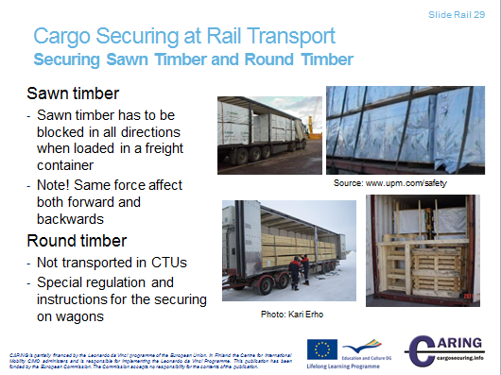
Securing Sawn Timber and Round Timber

Sawn and planed wood
Today sawn and planed wood is mainly transported in packages. There are packages of descending lengths and boards cut to a standardised length. If packages of both kinds are to be loaded on the same CTU, the packages of the same length should normally be loaded at the bottom to obtain a compact and stable first layer and to keep the centre of gravity as low as possible. The cargo should be secured by centre stanchions and top-over lashings. Also in the longitudinal direction the cargo must be secured, mainly by blocking against the headboard. Stable packages can be secured without centre stanchions or by long heavy pieces of dunnage between the layers.

Round timber
The transport process of round timber is such that after the logs are cut, timber is transported from the road side storage to a rail terminal, which is beside the rail depot or station. In the depot logs are loaded into rail wagons. Both wagons and cargo transport units in the trucks have same characteristics, typically having an open platform with stanchions in both sides.
Accordingly, the cargo loading and securing is implemented same way, but of course there are differences in securing because of different size and durability of the body and stanchions.
Typically the transport of round timber includes:
- Round timber will be transported with wagon or CTU that has stanchions on both sides.
- Place the load, whenever possible, against the headboard or similar restrains
- The load is transversely supported by at least two stanchions and with at least the same height as the load
- Use chain or web lashings with toggle or load binder

Notes

__________________________________________________________________________________

__________________________________________________________________________________

__________________________________________________________________________________

__________________________________________________________________________________

__________________________________________________________________________________

__________________________________________________________________________________

__________________________________________________________________________________

__________________________________________________________________________________

__________________________________________________________________________________

[Slide Rail 30]
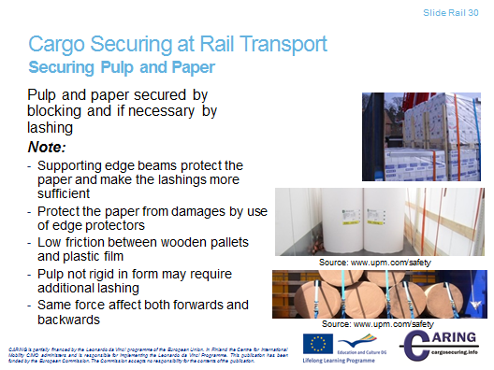
Securing Pulp and Paper
Paper products make a considerable share of transports. They are often transported in sea or railway systems organised by the different forest industries. But due to various circumstances a lot of paper products are also transported on cargo transport units outside the pure paper transport systems.
Paper reel
Usually for paper reel transports, the following parameters are of interest:
Weight: normally not exceeding 5 ton
Diameter: normally not exceeding 2 m
Width: varies in wide range up to 4,5 m
Paper reels can be transported laying on the reel or standing vertically on the end. The standing reels are not so much exposed to risks than laying reels. Because of the lack of equipment for handling standing reels some customers specify a transport of laying reels. Specifically, broad reels are transported in the laying position.
Note!
When transporting standing reels in a container, the reels that are beside the side walls are specifically exposed to damages, because the bottom edge of the wall has small protrusion, which can cause damages, though the small void space between reels and wall is filled with carton.

Sheet-paper on pallet
Sheet-paper are stowed on pallets to facilitate the paper handling. The sheet-papers are normally lashed to the pallet by shrink film and lashings. The pallets may be equipped with lids, protecting the sheet-paper on top when the pallets are stacked.
Sheet-papers are tailor-made in accordance with the customer’s order and there are an enormous amount of dimensions. Therefore the pallets are normally tailor-made by the same dimensions as the sheets. Some paper mills, however, try to use standardised pallets of slightly larger dimensions than the sheet-papers. Loading of pallets of larger dimensions than the sheet-papers causes voids in the stow, which is a source of transport damages.
General guidelines for the packing and securing of paper products
Paper products and especially paper reels are large transport commodities. Handling and transport of large and regular shipments are routine procedures.
When small quantities of paper products are transported there are often difficulties in the securing of the cargo, especially when more than one mode of transport is used in combination, e.g. road/sea.
The basic rules for loading and securing of cargo are also valid for paper products. Since most of these rules are important and applicable to every transport of cargo transport units, it is important to check the cargo planning against these rules.
By the built-in blocking system of the CTU, such as corner posts and walls in containers, headboard, sideboards and edges on trailers and flats, standing paper reels in one layer can be secured by dense stowing, in some cases completed with top-over lashings. Often Quick lashing guides are used to calculate the number of top-over lashings based on actual coefficient of friction, which is capable to meet the acting forces.
In cargo transport units without built-in blocking equipment, the paper reels must be secured in some other way. Different methods can be used solely or in combination.
Bottom blocking can be performed against sideboards or stanchions, but layer blocking is more difficult to arrange without damaging the paper. Instead it’s recommended to the friction to have well tensioned top-over lashings placed over edge supporting beams.
By lashing a number of reels together by round-turn lashings, the height/width ratio can be lowered and thereby the risk of tipping. If the reels are high and narrow, horizontal round-turn lashings can be used. When loading paper reels in containers, they can be blocked and then there is no risk of tipping. But loading paper reels on flat racks or on roll trailers and other CTU with any means for sideways blocking, round-turn lashing can be used to minimize the risk of tipping.
Securing of paper reels standing on the end in one and a half layer in soft-walled CTU:s
Most paper qualities and paper reel dimensions must be stowed in one and a half layer in a cargo transport unit to make use of the full payload of the CTU.
The paper reels in the second layer are prevented from moving forwards or backwards by raised units, in front of and behind the reels in the second layer. To prevent the paper reels in the second layer from tipping forwards or backwards, spring lashings or horizontal round-turn lashings are attached.
Because of the large bursting effect that may occur, careful designing of the cargo securing arrangement must be performed at all kinds of zigzag stowage. To prevent paper reels in the second zigzag stowed layer from moving sideways at hard braking or shunting, at least one round-turn lashing per three cargo sections is required.
Packing and securing of standing paper reels in one and a half layer in strong-walled CTU:s
Also in strong-walled cargo transport units like containers, the paper reels must as a rule be loaded in one and a half layer to make full use of the payload of the container. Paper reels, with a wider diameter than half the breadth of the CTU, can only be loaded in one row while more narrow reels can be loaded in several rows.
Because of the weight distribution the second layer must be located so, that it does not disturb the weight distribution of the unit. The second layer can be blocked by thresholds made by high paper reels in the bottom layer. If all reels are of the same height, the reels in front of and behind the top layer are raised by pallets or dunnage. The bottom layer is loaded tight to the front end wall of the unit while free space at the doors is blocked with filling material.
In front of and behind the top layer high paper reels are placed. If all reels are of the same height, the reels in front of and behind the top layer are raised by pallets or dunnage. To prevent the paper reels in the top layer and the rear reels in the bottom layer from tipping forwards or backwards, round-turn lashings may be used.
Packing and securing of standing paper reels with a large diameter in one or more layers in strong-walled CTU:s
When the paper reels have a diameter wider than half the CTU breadth they can only be loaded in one row. To utilise the maximum CTU length and at the same time support the paper reels on at least three places on the reel, they can be densely loaded in a zigzag pattern from the front end wall of the CTU. The rear reels are secured by a dunnage bag between the two last reels and filling material from the last reel to the rear wall. In a container blocking is to be made against the left door. Note, never use air bags directly against the doors.
Because of the weight distribution a second layer must be located so, that it does not disturb the weight distribution of the unit. In front of and behind the top layer high paper reels are placed. If all reels are of the same height, the reels in front of and behind the top layer are raised by pallets or dunnage.
Packing and securing of lying reels in one and a half layer in soft-walled CTU:s
If, depending on demands from the customer, the paper reels must be transported laying on the roll, they should be loaded with their axles across the CTU. To make use of the full payload, also the lying reels must usually be loaded in more than one layer.
The bottom layer is placed tight to the headboard and each paper reel is secured by small chocks to make the handling of each reel easier. The reels at the end of the cargo transport unit must be secured against backward movements by properly fixed chocks of a height of half the reel radius. For railway transports, the height of the chocks must be at least 20 cm for reels with a diameter over 80 cm.
The paper reels in the top layer should be secured against forward movement in the CTU by securing of the first reel in each row to the reels in the lower layer by vertical round-turn lashings. The securing to prevent the reels from tipping or the reels in the second layer from sliding should be designed according to the basic cargo securing.
Packing and securing of laying reels in one and a half layer in strong-walled CTU:s
When loading laying reels in strong-walled units, the walls are used for securing. The reels are placed along the sides and possible void is left in the middle. The void is filled by e.g. air dunnage bags. Also empty pallets or blocking braces can be used. The reels are secured longitudinally in the same way as in soft-walled units.
Packing and securing of sheet-paper on pallets in one and a half layer in soft-walled CTU:s
To lower the risk of tipping sideways, the paper sheet pallets are preferably loaded by their widest sides across the cargo transport unit. If the CTU would be filled to the weight limit by sheet-paper, it is necessary for most of the pallet dimensions to put a certain number of pallets in a second layer.
The pallets in the bottom layer are placed dense to the headboard to prevent the first layer from moving forward. Movement backwards is prevented by filling possible void between pallets and rear board for example by empty pallets.
If the pallets are not densely stowed between the sideboards they must be prevented from sliding and tipping sideways by blocking and/or lashing according to the basic cargo securing principles.
If the weight distribution in the CTU permits, also the pallets in the second layer should be placed dense to the headboard. If they must be placed in the middle of the CTU, they can be prevented from moving forwards by a spring lashing. To protect the cargo, a spring lashing placed over a pallet should be used. As an alternative to spring lashing, a solid board can be placed between pallets in the lower layer. The board must be high enough to give a sufficient support to the pallets in the top layer. If the CTU is to be transported by rail, there is also a need of heavy blocking preventing the top layer from moving backwards. The pallets in the top layer are prevented from moving sideways according to the basic cargo securing principles.
Packing and securing of sheet-paper on pallets in one and a half layer in strong-walled CTU:s
As for paper reels the strong walls are used for securing the cargo from moving sideways. The pallets are densely stowed against the walls and possible void is left in the middle of the unit. If the pallets are not square, the void must be placed on the right and on the left side to locate the centre of gravity transversally in the centre of the unit. The empty space should be blocked by air dunnage bags, empty pallets or braces. If air dunnage bags are used fibreboard may be necessary as protection against sharp edges.
The bottom layer should be densely stowed against the front wall and possible voids at the doors should be blocked. The pallets in the top layer can be protected from moving forwards and backwards by solid boards and vertical round-turn lashings. For rail transport, blocking is necessary in both travelling directions.

Notes

__________________________________________________________________________________

__________________________________________________________________________________

__________________________________________________________________________________

__________________________________________________________________________________

__________________________________________________________________________________

__________________________________________________________________________________

__________________________________________________________________________________

__________________________________________________________________________________

__________________________________________________________________________________

