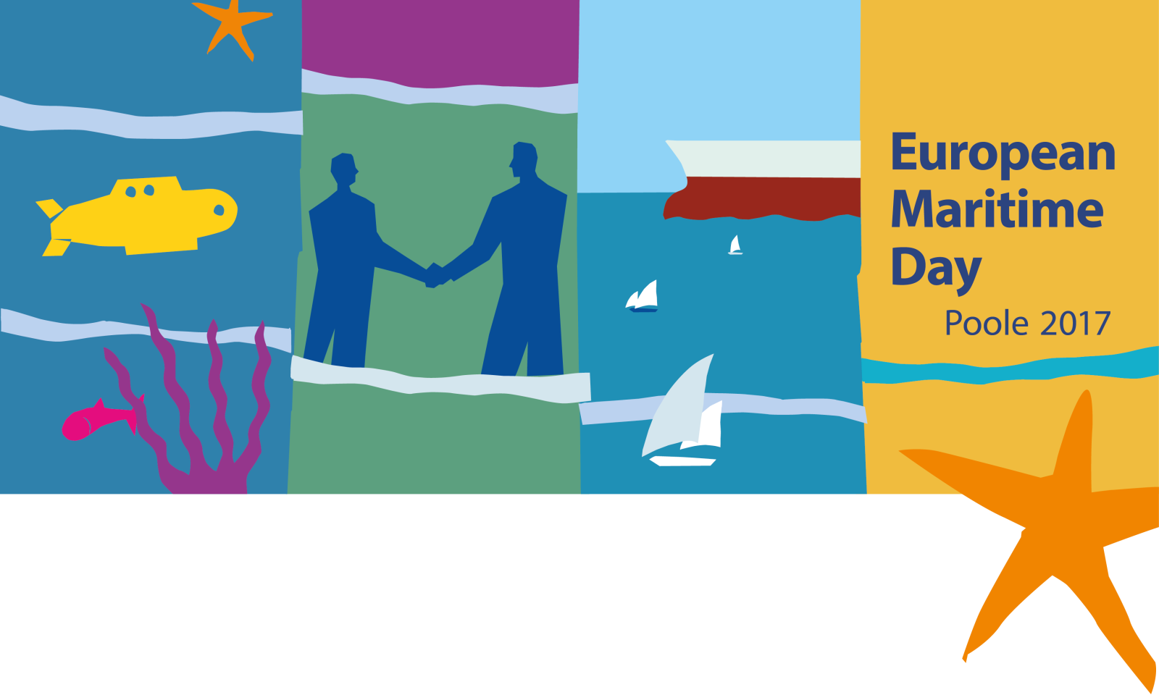

**European Maritime Day 2017**

"***The Future of our Seas***"

18-19 May, Poole, UK

List of workshops

Venue: Lighthouse Arts & Conference Centre in Poole

Interpretation: English, French and German. Interpretation is provided only in the Plenary Room.

Interact with: [~~#~~**EMD2017**](https://twitter.com/hashtag/EMD2017?src=hash) **/** [**@EU_MARE**](https://twitter.com/EU_MARE) **/** [**Facebook/EUmaritimefish**](https://www.facebook.com/EUmaritimefish/)

Day 1 – Thursday, 18 May 2017

***Workshop themes:***

***(1) Innovation & Growth***

***(2) People & Skills***

***(3) Sustainability & Governance***

***(4) Safety & Security***

*\*Workshops proposed and organised by maritime stakeholders.*

13.30 – 15.00 **PARALLEL WORKSHOPS**

4 - Towards a blue bioeconomy: from research to market

5- Enabling and Cross-Cutting Maritime Technologies

12 - Blue Economy needs Ocean Literate citizens

15 - Maritime Ideas Café: Funding of projects

19 - Marine plastics: a review of impacts and solutions

20 - Inspiring engagement for a sustainable future for our seas

26 - EUCISE2020 - the crucial step in achieving CISE Preparedness at Sea: Developing & Sharing Practices

15.00 – 15.15 Coffee Break

15.15 – 16.45 **PARALLEL WORKSHOPS**

1 - EU Funding for highly innovative Small Businesses

6 - Creative disruption – Maritime start-ups

9 - Sea basin strategies delivering regional growth

14 - The Greatest Coastal Monitoring Future: Citizens

16 - Blue Growth Data Challenge Part 1: Engaging Industry

23 - Smart (Port) Cities

24 - Preparedness at Sea: Developing & Sharing Practices

16.45 – 17.00 Coffee Break

17.00 – 18.30 **PARALLEL WORKSHOPS**

3 - Ocean renewable energy: For people & ports

7 - To be or not to be (in blue growth)

10 - Digitalisation - Opportunities Attract

11 - MSP: Resolving Transboundary issues

17 - Blue Growth Data Challenge Part 2: Offshore Energy Case Studies

22 - "More fish, more jobs, more money." Towards the recovery of European fisheries.

Project pitch presentations on Sustainability & Governance

25 - Satellite EO technologies for law enforcement

18.30 – 21.00 Networking Reception (Poole Park)

Day 2 – Friday, 19 May 2017

08.30 – 10.00 **PARALLEL WORKSHOPS**

2 - Maritime Innovation Clustering for success

8 - IMTA: An environmental opportunity for aquaculture

13 - New skills for the maritime Economy

Project pitch presentations on People & Skills

18 - Delivering Good Marine Status and Blue Growth?

21 - Maritime air pollution in the Arctic and beyond

10.00 – 10.25 Coffee Break

**